

Navio: ev trip planner platform
(Thailand focused)

mr. suriya upariphutthiphong
mr. prapangkorn thangsathityangkul
mr. supakrit duangsri

A SENIOR PROJECT SUBMITTED IN PARTIAL FULFILLMENT
OF THE REQUIREMENTS FOR THE DEGREE OF
BACHELOR OF SCIENCE
(COMPUTER SCIENCE)
SCHOOL OF INFORMATION TECHNOLOGY
KING MONGKUT'S UNIVERSITY OF TECHNOLOGY THONBURI
2026

Navio: EV Trip Planner Platform
(Thailand Focused)

Mr. Suriya Upariphutthiphong 66130500858
Mr. Prapangkorn Thagsathityangkul 66130500848
Mr. Supakrit Duangsri 66130500856

B.Sc. (Computer Science)
A Senior Project Submitted in Partial Fulfillment
of the Requirements for the Degree of
Bachelor of Science (Computer Science)
School of Information Technology
King Mongkut's University of Technology Thonburi
2026

Project Committee

………………………………………………. Member and Project Advisor
(Aj. Ekapong Jungcharoensukying)

………………………………………………. Member
(Asst. Prof. Dr. Chakarida Nukoolkit, Ph.D.)

………………………………………………. Member
(Assoc. Prof. Dr. Jonathan Hoyin Chan, Ph.D.)

………………………………………………. Member
(Assoc. Prof. Dr. Vajirasak Vanijja, Ph.D.)

………………………………………………. Member
(Dr. Vithida Chongsuphajaisiddhi, Ph.D.)

Copyright reserved
Thesis Title Preparation and Enaluation of Black Chrome Selectives on Low Carbon Steel and Aluminu Substrate
Thesis Credits 12
Candidate Miss Nandh Thavarungkul
Thesis Advisors Asst. Prof. Dr. Thumrongrat Amornraksa
Asst. Prof. Dr. Name Sername
Program Master of Engineering
Field of Study Computer Engineering
Department Computer Engineering
Faculty Engineering
Academic Year 2015

Abstract

[data]
[data]
Keywords : [Such as Aluminium Surface / Black Chrome (Selective Surface) / [Such as Aluminium Surface

ACKNOWLEDGEMENTS

[Text]
[Text]

ไม่ต้องลงท้ายชื่อผู้เขียน

Contents

CHAPTER 1 INTRODUCTION 1
1.1 Background Information 1
1.2 Objectives 2
1.3 Scope 2
1.4 Expected Benefits 3
Chapter 2 Feasibility Study 4
2.1 Introduction 4
2.2 Problem Statement 4
2.3 Related Research & Projects 4
2.4 Requirement Specifications 6
2.5 Implementation Techniques 6
2.6 Implementation Plan 7
Chapter 3 12

Chapter 1 Introduction

Background Information
Planning a road trip requires a traveler to coordinate destinations, travel times, accommodation and activities across several days. An electric vehicle introduces additional considerations, including the battery level at departure, the distance between stops, compatible charging connectors and the time required to recharge. The International Energy Agency identifies vehicle deployment and charging infrastructure as related elements of the transition to electric mobility [1]. For an individual journey, however, the existence of charging infrastructure does not by itself establish that a particular itinerary is practical.
Travelers can use mapping applications to inspect routes, itinerary applications to organize activities, charging applications to locate stations, and community discussions to obtain advice. These tools have useful capabilities, but a traveler may still need to transfer information between them. For example, moving an attraction to a different day can change driving distance and the charging stops required later in the trip. A planning interface should therefore connect itinerary changes with their implications for the selected vehicle.
NAVIO is a web-based EV trip planner platform with an initial emphasis on travel in Thailand. It brings itinerary organisation, EV-related planning, shared travel plans and community discussions into one workflow. The planner remains useful for organising an ordinary trip, while vehicle selection enables additional battery and charging information. Explore provides a separate entry point for discovering publicly shared itineraries and copying a suitable plan for personal customisation.
The project treats an energy prediction as a planning estimate rather than a guarantee of the battery level that will occur on the road. Vehicle data may have different measurement bases, while traffic, driving behavior and operating conditions can affect actual consumption. Similarly, a listed charging station is not a reservation or a guarantee of service. NAVIO consequently distinguishes known specifications, estimated values, user observations and unavailable information. This distinction is important both for presenting useful information and for avoiding misleading confidence in an incomplete prediction.

1.2 Objectives
The primary objective is to design and develop a web application that combines structured trip planning with EV charging considerations and reusable travel information. The specific objectives are as follows:
- To provide a day-by-day planner for creating, editing and organizing destinations, stops, notes and related trip information, with route visualization and distance and duration estimates.
- To integrate vehicle selection, charging-station discovery, connector compatibility, battery-state estimation and charging-stop planning into the itinerary workflow.
- To provide Explore functionality through which users can publish selected trip information, browse shared plans and create independent personal copies.
- To provide a community forum for travel discussions, EV experiences and conversations associated with shared plans.
- To evaluate the correctness of the implemented workflows through software testing, and to define further user and route-based evaluation needed to assess practical usefulness.
AI Assistance is a conditional supporting feature. If time remains after the main features are stable, it may assist with itinerary drafts or suggestions while leaving the traveler in control of changes. Completion of the main objectives does not depend on implementing AI Assistance.

1.3 Scope

1.3.1 Main Features
The project comprises four main feature areas: the Base Planner System, EV Integration, Explore and Community Forum. Account management, data persistence and operational infrastructure support these areas rather than constituting separate user-facing main features.
The Base Planner System covers creating trips, specifying dates and destinations, arranging day-by-day stops, modifying their order, attaching planning information and displaying routes on a map. It supports saved account trips and a guest planning experience. Notes, checklists, expenses and map export support itinerary organisation where available in the implemented workflow.
EV Integration covers catalogue and custom vehicle selection, trip-specific vehicle membership, charging-station discovery, compatibility filtering, manual charger insertion and energy-aware charging-stop planning. It also covers a starting battery level for the trip, predicted battery propagation and optional actual battery observations at itinerary stops. Automatic planning is subject to available route and vehicle data and the eligibility rules of the selected energy model.
Explore covers publication of travel plans, public browsing, viewing a shared itinerary and creating a personal copy. Publication is separate from editing the owner's private trip. The receiving user can customise a copy without changing the original. Search and discovery functions should operate on the available shared-plan dataset; they do not imply that every travel destination has a prepared plan.
Community Forum covers browsing discussions and groups and, for authenticated users, creating posts, commenting and participating in supported community interactions. Shared plans can provide context for related discussions. Community content represents user contributions and should not be presented as independently verified charging-station telemetry.

1.3.2 Supporting and Conditional Features
Authentication and ownership controls protect private trips; personal vehicle lists and account operations. Guests may browse public information and use temporary planning facilities, but account persistence and authenticated contributions require sign-in. Reusable custom vehicle definitions belong to the user's personal list, while the vehicles shown in a trip's garage belong to that trip.
AI Assistance is a supporting feature considered only after the main system is stable and sufficient development time remains. A separate place-recommendation experience within Explore is also a possible extension. Neither capability is treated as part of the completed implementation described in this report.

1.3.3 Boundaries
The deliverable is a browser-based application rather than a native mobile application. Thailand is the primary project context, although the location model and external map providers can represent destinations in other countries. Availability of vehicle and charging data may differ between locations.
Automated content moderation, user-report adjudication and automatic replacement of reported plans are outside the current feature scope. Basic access control and administration remain necessary for operating the application. Charging payments, charger reservations, control of physical charging equipment, continuous vehicle telemetry and guaranteed live charger availability are not provided by the planner.
The project does not claim a globally optimal route, experimentally validated battery accuracy or measured reductions in travel cost or anxiety. Such claims require an evaluation beyond implementation tests. Weather-aware prediction, learned consumption calibration and detailed battery charging curves are not assumed in the present nominal model.

1.4 Expected Benefits
NAVIO is intended to reduce the effort required to organise itinerary and EV information in separate tools. A traveller can inspect planned activities and the associated route while considering where compatible charging may be needed. Reusable shared plans can reduce repeated itinerary entry, and an independent copy allows the traveller to adapt an example to different dates or preferences.
Vehicle-specific inputs and explicit handling of missing data are expected to make estimates easier to interpret. A traveller can distinguish an authoritative specification from a provisional range-based estimate and can supply an observed battery level without changing the underlying vehicle definition. Community discussions provide an additional channel for experience and advice.
For the project team, the application demonstrates integration of a stateful web interface, service APIs, relational persistence, geospatial providers and access control. These are expected benefits of the design. Their effect on usability and travel outcomes should be measured through the evaluation described in Chapter 4.

Chapter 2 Feasibility Study

2.1 Introduction
This chapter examines the problem addressed by NAVIO, relevant applications, system requirements and the feasibility of the chosen implementation approach. The project follows an iterative development strategy: establish a functioning planner, integrate the main feature areas, validate their interactions, and consider conditional extensions only after the core workflows are stable.
The feasibility assessment recognizes two different questions. Technical feasibility concerns whether the application can retrieve data, maintain trips and calculate consistent estimates. Practical validity concerns whether those estimates and workflows are sufficiently useful under real travel conditions. Software tests provide evidence for the first question, but cannot alone answer the second.

2.2 Problem Statement

2.2.1 Coordination of Itinerary and Charging Information
A multi-day itinerary is more than a route between two coordinates. It includes the order of visits, daily start and end locations, saved alternatives and optional planning notes. A change to one stop can affect the distance to subsequent stops. When charging decisions are made in a separate application, the traveler must reconcile those changes manually.
NAVIO addresses this coordination problem by associating route and vehicle information with the itinerary. The purpose is not to replace every navigation or charging-operator application. Instead, the project provides a planning workspace in which the user can consider activities and charging together before using an appropriate navigation or operator service during travel.

2.2.2 Incomplete and Unequal Vehicle Data
Available vehicle information may include rated range, declared battery capacity, connector types and charging power, but not a suitable direct consumption specification. A declared battery capacity is not necessarily usable capacity. Likewise, a rated-range test standard does not establish the measurement standard of a separate consumption figure.
Treating all such inputs as interchangeable would conceal uncertainty. The system therefore requires a data contract that records provenance and selects an explicit energy model. An unavailable input should lead to a limited or unavailable result, rather than an apparently precise number based on an undocumented assumption.

2.2.3 Charging and Shared Information Limitations
Charger location, connector compatibility and operational availability are different properties. Map-provider data can support station discovery without proving that a connector will be free or compatible upon arrival. User discussions may provide useful context but are not a substitute for verified operator status.
Shared itineraries also need clear ownership and publication boundaries. Editing a private plan should not unexpectedly alter a previously published representation, and copying a plan should not transfer private account data. These requirements make publication and copying more than simple duplication of a database record.

2.3 Related Research & Projects

2.3.1 General Itinerary Planning
Wanderlog provides itinerary organization, map-based travel planning and route-related information [2]. It is a relevant reference for presenting places, dates and travel details together. Its published product information demonstrates that general itinerary tools already support substantial planning functionality. NAVIO therefore does not claim that itinerary organization or route planning is new in itself.
The relevant design question is how to combine this style of itinerary interaction with vehicle provenance, chronological battery state and charging-stop decisions. The comparison is based on documented product capabilities rather than an assumption that competing applications have no EV-related functionality.

2.3.2 EV Charging and Route Applications
PugEV's official site describes charging-station discovery, station details, connector information and route-based station browsing in Thailand [3]. These functions are directly relevant to EV travelers. Its published trip-planning capability means it would be inaccurate to describe the application simply as having no trip-planning functions.
Saifah was also considered as an EV-oriented reference during the project's feasibility and design presentations [8]. The project does not rely on an unverified exhaustive comparison of its current feature set. The useful distinction for NAVIO is the intended integration of a multi-day itinerary workspace, reusable shared plans and community context, rather than a claim that EV route applications are merely maps.

2.3.3 Mapping and Placing Data
Google Routes provides route computation facilities, while Google Places provides place search and place information [4, 5]. These services support location selection and the calculation of route distance and duration. They are external data sources, not NAVIO's battery model. NAVIO must combine route results with the selected vehicle model and maintain its own itinerary state.
Provider responses may be incomplete or unavailable, so the application must distinguish a routed distance from a fallback approximation. A straight-line distance may help display incomplete information, but must not be silently treated as equivalent evidence for a road-based reachability decision.

2.3.4 Position of NAVIO
NAVIO combines four related workflows: constructing an itinerary, considering EV constraints, discovering reusable plans and discussing travel information. The contribution is this integrated workflow and its handling of vehicle and trip state. The project does not claim that no other platform combines any of these capabilities, or that its estimates are more accurate without comparative evaluation.
Table 2.1 summarises the design references. It is a qualitative comparison of the capabilities relevant to this project, not a benchmark of all features or current commercial performance.
Reference | Relevant documented capability | Relevance to NAVIO
Wanderlog | Itinerary organisation, maps and route-related planning | Day-based itinerary presentation and organisation
PugEV | Charger discovery, connector details and stations along a route | EV data presentation and charging discovery
Google Routes and Places | Route computation, place search and place details | External route and location data
NAVIO | Integrated planner, EV model, Explore and community | Project implementation and evaluation subject
Figure 2.1: Shows table of comparison for related systems and their relevance

2.4 Requirement Specifications

2.4.1 Functional Requirement
The functional requirements describe observable behavior rather than particular interface layouts. Table 2.2 groups them by the main workflows. Conditional enhancements are separated from the core requirements so that an unfinished optional feature does not obscure evaluation of the base system.
ID | Requirement
FR01 | Allow public browsing and temporary guest planning while protecting account operations.
FR02 | Create and edit a trip with dates, destinations and day-based itinerary blocks.
FR03 | Add, reorder and remove stops and supporting notes or checklist items.
FR04 | Display route geometry and available distance and duration information.
FR05 | Select a catalogue or custom EV and maintain trip-specific garage membership.
FR06 | Preserve vehicle energy provenance and explicit default, range or custom selection.
FR07 | Propagate battery state from the trip start through stops and days, including observations.
FR08 | Discover chargers, inspect available specifications and insert a chosen station.
FR09 | Preview and apply eligible charging-stop changes with version and feasibility checks.
FR10 | Publish a controlled public plan representation and create independent personal copies.
FR11 | Browse community content and support authenticated posts, comments and interactions.
FR12 | Preserve saved trip state and prevent access to another user's private resources.

Figure 2.2: Shows table of core functional requirements
AI-generated itinerary assistance and an additional place-recommendation mode in Explore are conditional enhancements. If implemented, their outputs must remain editable and must not bypass ownership, route validation or energy-model rules.

2.4.2 Nonfunctional Requirements
The application should remain understandable when data is missing. Unavailable route, energy or charging values must be distinguishable from zero. Validation should reject invalid battery percentages and malformed requests, while failed persistence should not be presented as successful saving.
Security requirements include authenticated writes, resource ownership checks and a restricted public read surface. Catalogue browsing and published plans can be public without exposing a personal garage or private itinerary. Secrets belong in server-side configuration rather than browser-delivered code.
The interface should support desktop and narrow browser layouts, readable contrast, keyboard access and clear form labels. Performance evaluation should record response time and failure rate under a stated environment and workload. The report does not assert a concurrency capacity or response-time guarantee that has not been measured.

2.5 Implementation Techniques
To h

2.6 Implementation Plan
The NAVIO project

Chapter 3 System Analysis & Design

3.1 Analysis of the Existing System
The current approach to planning trips, particularly for Electric Vehicle (EV) users, relies on the use of multiple independent platforms and services. Travelers are often required to switch between navigation applications, trip planning tools, EV charging station locators, travel blogs, and online discussion forums to gather the information necessary for a single journey. Because these systems operate independently and are not designed to exchange information with one another, users must manually verify route feasibility, charging availability, and destination details. This fragmented workflow increases planning complexity, consumes significant time, and may lead to uncertainty during travel.

For conventional vehicle users, route planning primarily involves selecting destinations and navigation paths. However, EV users face additional constraints including battery range, charging station availability, connector compatibility, charging duration, and charger reliability. Existing platforms provide partial solutions to these challenges but fail to offer a comprehensive system that combines itinerary management, EV-aware routing, and community-driven verification within a single platform.

3.1.1 Google Map System
Google Maps is one of the most widely used navigation platforms and provides accurate route guidance, travel time estimation, and location search capabilities. Users can search for destinations, calculate routes, and view nearby points of interest.
Current Workflow
- User enters a destination or multiple destinations.
- Google Maps calculates the optimal route based on distance and traffic conditions.
- The system displays navigation instructions and estimated arrival times.
- Users may manually search for EV charging stations during the trip.
Limitations
- No dedicated trip planning functionality for multi-day itineraries.
- Limited support for organizing activities and schedules.
- EV charging stations are treated as ordinary points of interest rather than integral route components.
- Does not provide charger reliability information or community verification.

3.1.2 Wanderlog System
Wanderlog is a popular trip planning platform that enables users to create detailed itineraries, organize destinations, and collaborate with travel companions.
Current Workflow
- Users create a trip and add destinations or activities.
- Destinations are organized into daily schedules.
- Routes are generated between locations.
- Trips can be shared and collaboratively edited.
Limitations
- Designed primarily for general tourism planning.
- No EV-specific route optimization.
- Does not consider battery range limitations.
- Charging station planning must be performed using external applications.
- Lacks charger compatibility and charging safety calculations.

3.1.3 EV Charger Locator Application (Saifah & PUGEV)
Applications such as Saifah and PUGEV focus on helping EV drivers locate charging stations and monitor charger availability.
Current Workflow
- Users search for nearby charging stations.
- The system displays station locations and available charger types.
- Users navigate to the selected charging station.
- Some platforms provide charger status updates and user feedback.
Limitations
- Focus primarily on charging station discovery.
- Do not provide comprehensive trip planning functionality.
- Lack support for multi-stop itinerary management.
- Cannot generate complete travel plans that integrate destinations and charging requirements.
- Users must combine these applications with external trip planning tools.

3.1.4 Travel Blogs and Community Forums
Travel blogs and online communities provide valuable travel experiences, destination recommendations, and practical advice from other travelers.
Current Workflow
- Users search for information through websites, forums, or social media groups.
- Community members share travel experiences and recommendations.
- Travelers manually extract useful information for trip planning.
Limitations
- Information is scattered across multiple platforms.
- Content may be outdated or difficult to verify.
- Discussions are often unrelated to specific travel plans.
- No structured integration with route planning systems.
- EV-related information is often limited or incomplete.

3.1.5 Challenges in the Existing System
The analysis of existing systems reveals several significant challenges:
Fragmented Planning Process:
Users must rely on multiple independent applications to complete a single trip planning task. Route planning, EV charging discovery, travel recommendations, and community discussions are separated across different platforms.
Lack of EV-Aware Trip Planning:
Most trip planning platforms assume unlimited refueling availability and do not consider battery range, charging frequency, or charging station compatibility when generating routes.
Charger Reliability Uncertainty:
Existing systems provide charger locations but often fail to indicate whether chargers are operational, occupied, under maintenance, or compatible with a specific vehicle.
Limited Community Integration:
Travel discussions and charger experiences are distributed across forums and social media platforms, making it difficult for users to locate reliable and relevant information.
Inefficient Decision-Making:
The need to repeatedly switch between multiple tools increases planning complexity, creates uncertainty, and discourages long-distance EV travel.
These limitations demonstrate the need for an integrated platform that combines trip planning, EV route optimization, charging station awareness, plan sharing, and community-driven verification within a single system. The proposed NAVIO platform aims to address these shortcomings by providing a unified travel planning experience specifically designed for EV users in Thailand.

3.2 User Requirement Analysis
stem.

3.3 New System Design

3.3.1 Site Map
Figure 3.1: Shows Site Map Diagram
- Will be done at later phase -

3.3.2 Frontend & Backend System
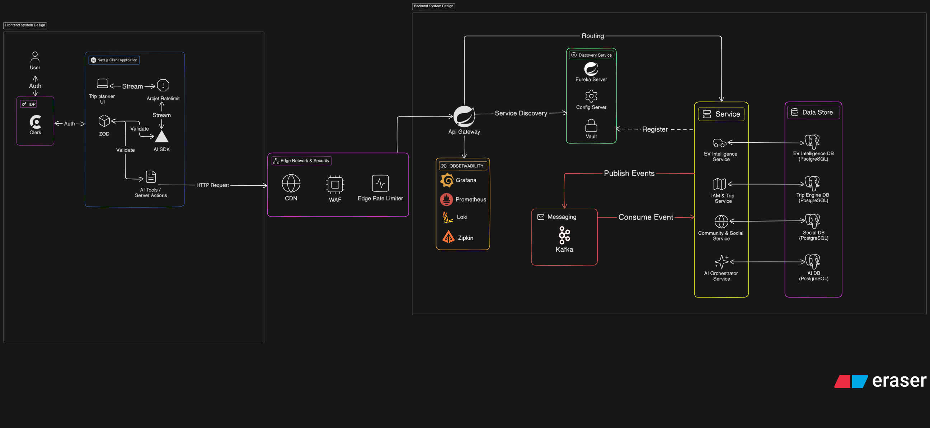
Figure 3.2: Shows Frontend & Backend System Design
Figure 3.2 illustrates the overall architecture of NAVIO, which adopts a microservices-based architecture to improve scalability, maintainability, and reliability. The system is divided into several layers, including the frontend layer, security layer, backend services layer, data storage layer, and monitoring layer.
Frontend Layer:
The frontend is developed using Next.js and provides the main interface for trip planning, EV charger discovery, community interaction, and AI-assisted travel planning. Clerk handles user authentication and session management, while Zod validates user input before requests are processed. The AI SDK enables communication with AI services for itinerary generation and travel recommendations.
Edge Network & Security Layer:
All incoming requests pass through a security layer consisting of a CDN, Web Application Firewall (WAF), and Edge Rate Limiter. These components improve application performance while protecting the system from malicious requests and abuse.
Backend Services Layer:
The backend utilizes an API Gateway as the central entry point for client requests. Service discovery and configuration management are handled by Eureka Server, Config Server, and Vault.
The system consists of four core services:
- IAM & Trip Service – Manages user authentication, authorization, user profiles, trip creation, itinerary planning, trip collaboration, budget management, and trip-sharing functionalities.
- EV Intelligence Service – Handles charging station information, EV routing, charging recommendations, charger reviews, and EV travel intelligence.
- Community & Social Service – Manages community discussions, shared travel plans, social interactions, comments, and notifications generated from community activities and system events.
- AI Orchestrator Service – Coordinates communication with AI models and provides AI-assisted itinerary generation, trip modification, and travel recommendations.
Event Communication Layer:
Apache Kafka is used for asynchronous communication between services. This event-driven approach improves scalability and reduces direct dependencies between system components.
Data Storage Layer:
Each service maintains its own PostgreSQL database to ensure data isolation and independent scalability. The system includes dedicated databases for Trip, EV, Community, and AI services.
Observability Layer:
System monitoring is supported by Prometheus, Grafana, Loki, and Zipkin, which provide metrics collection, dashboard visualization, log aggregation, and distributed tracing.
Data Storage Layer:
Each service maintains its own dedicated PostgreSQL database following the database-per-service architecture.
The system consists of:
- Trip Engine Database – Stores user information, authentication data, trips, itineraries, travel schedules, budgets, and collaboration records managed by the IAM & Trip Service.
- EV Intelligence Database – Stores charging station information, charger reviews, EV routing data, and charging recommendations managed by the EV Intelligence Service.
- Social Database – Stores community discussions, shared travel plans, comments, notifications, and social interaction records managed by the Community & Social Service.
- AI Database – Stores AI sessions, prompts, generated responses, tool invocations, and usage records managed by the AI Orchestrator Service.
This separation improves data isolation, service independence, and overall system scalability.

3.3.3 Data Flow Diagram
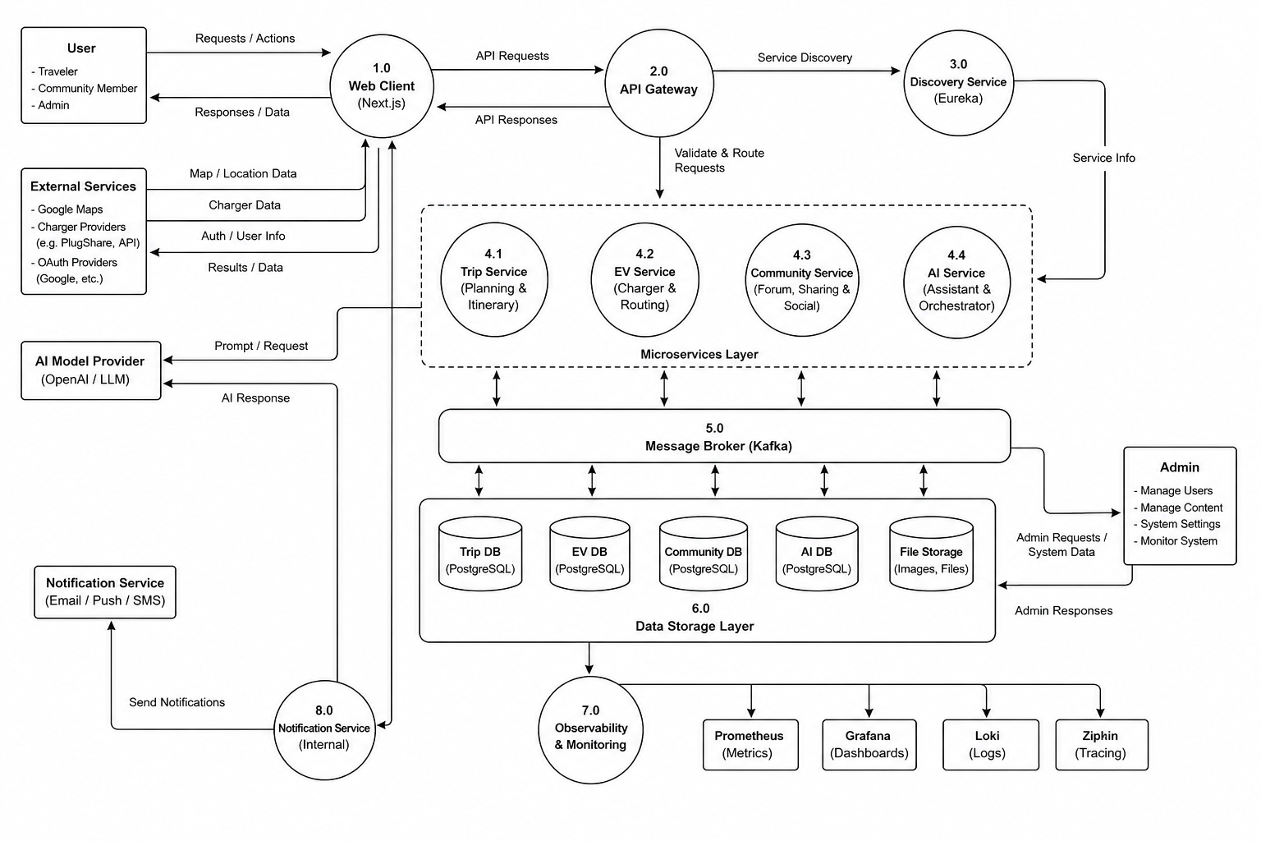
Figure 3.3: Shows Data Flor Diagram
The diagram shows how user requests are processed through the frontend application, routed to backend services, stored in dedicated databases, and returned to users. It also demonstrates the interaction between external services, AI providers, notification systems, and monitoring components.
Web Client: The data flow begins when users interact with the NAVIO web application through the Web Client. Users can create trips, manage itineraries, explore EV charging stations, participate in community discussions, and request AI-assisted travel planning. The Web Client receives user requests and forwards them to the API Gateway while displaying the returned results to users.
API Gateway and Service Discovery: The API Gateway acts as the central entry point for all requests. It validates incoming requests and routes them to the appropriate backend service. To determine the correct destination, the gateway communicates with the Discovery Service, which maintains information about all available services within the system.
Microservices Layer: Once routed, requests are processed by the corresponding microservice. The Trip Service manages trip planning and itinerary-related operations. The EV Service handles charging station information, EV routing, and charging recommendations. The Community Service manages shared plans, discussions, notifications, and social interactions. The AI Service processes AI-assisted itinerary generation and travel recommendations.
External Service Integration: Several external services provide additional data required by the platform. Authentication providers supply user authentication information, mapping services provide location and navigation data, while charging station providers supply charger information. For AI-related requests, the AI Service communicates with external AI model providers and returns generated responses to users.
Message Broker: Communication between services is supported by Apache Kafka, which acts as a message broker. Services can publish and consume events asynchronously, allowing information to be exchanged efficiently while reducing direct dependencies between system components.
Data Storage Layer: Processed information is stored within dedicated databases. Trip-related data is stored in the Trip Database, EV information is stored in the EV Database, community content is stored in the Community Database, and AI-related information is stored in the AI Database. Media files such as images and uploaded content are stored separately within the file storage system.
Notification Service: System-generated events may trigger notifications for users. The internal Notification Service processes these events and forwards notification requests to external providers, which deliver notifications through email, push notifications, or SMS channels.
Observability and Monitoring: Operational data generated by the system is collected by the observability layer. Monitoring tools such as Prometheus, Grafana, Loki, and Zipkin gather metrics, logs, and traces to support system monitoring, performance analysis, and troubleshooting activities.

3.3.4 ER Diagram
1) Trip ER Diagram
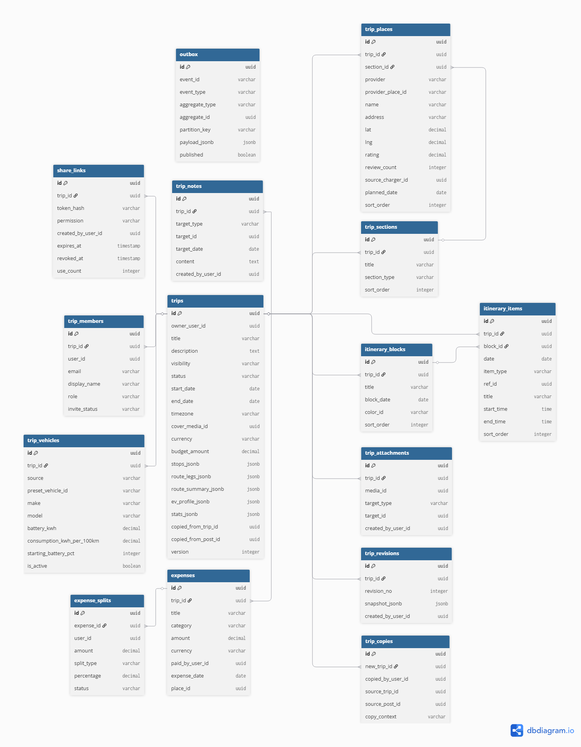
Figure 3.4: Shows Trip ER Diagram
Figure 3.4 illustrates the ER Diagram of the Trip Database, which manages trip planning, itinerary organization, collaboration, budgeting, and EV-related travel information. The database is centered around the trips table, which stores the primary information of each travel plan and acts as the parent entity for most trip-related records.
Trip Structure Management: The trip_sections, trip_places, itinerary_blocks, and itinerary_items tables are used to organize travel plans into structured itineraries. These entities allow users to arrange destinations, activities, and schedules according to specific dates and trip segments.
Vehicle Information: The trip_vehicles table stores vehicle information such as battery capacity, energy consumption rate, and starting battery level. This data supports EV route planning and charging recommendation functionalities.
Expense Management: The expenses and expense_splits tables manage trip-related expenditures and cost sharing among participants. This enables users to track budgets and distribute expenses during collaborative trips.
Collaboration and Sharing: The trip_members table stores participant information and roles, while the share_links table manages trip-sharing permissions and access control. Together, these entities support collaborative trip planning and plan sharing.
Additional Resources: The trip_notes and trip_attachments tables store supplementary information such as notes, documents, and media files associated with a trip.
Version Control and Event Processing: The trip_revisions and trip_copies tables support trip history tracking and plan duplication. In addition, the outbox table stores domain events before they are published to other services, supporting the system's event-driven architecture.
Overall, the Trip Database provides a structured foundation for managing travel plans, destinations, schedules, budgets, and collaboration features within the NAVIO platform.

2) EV ER Diagram
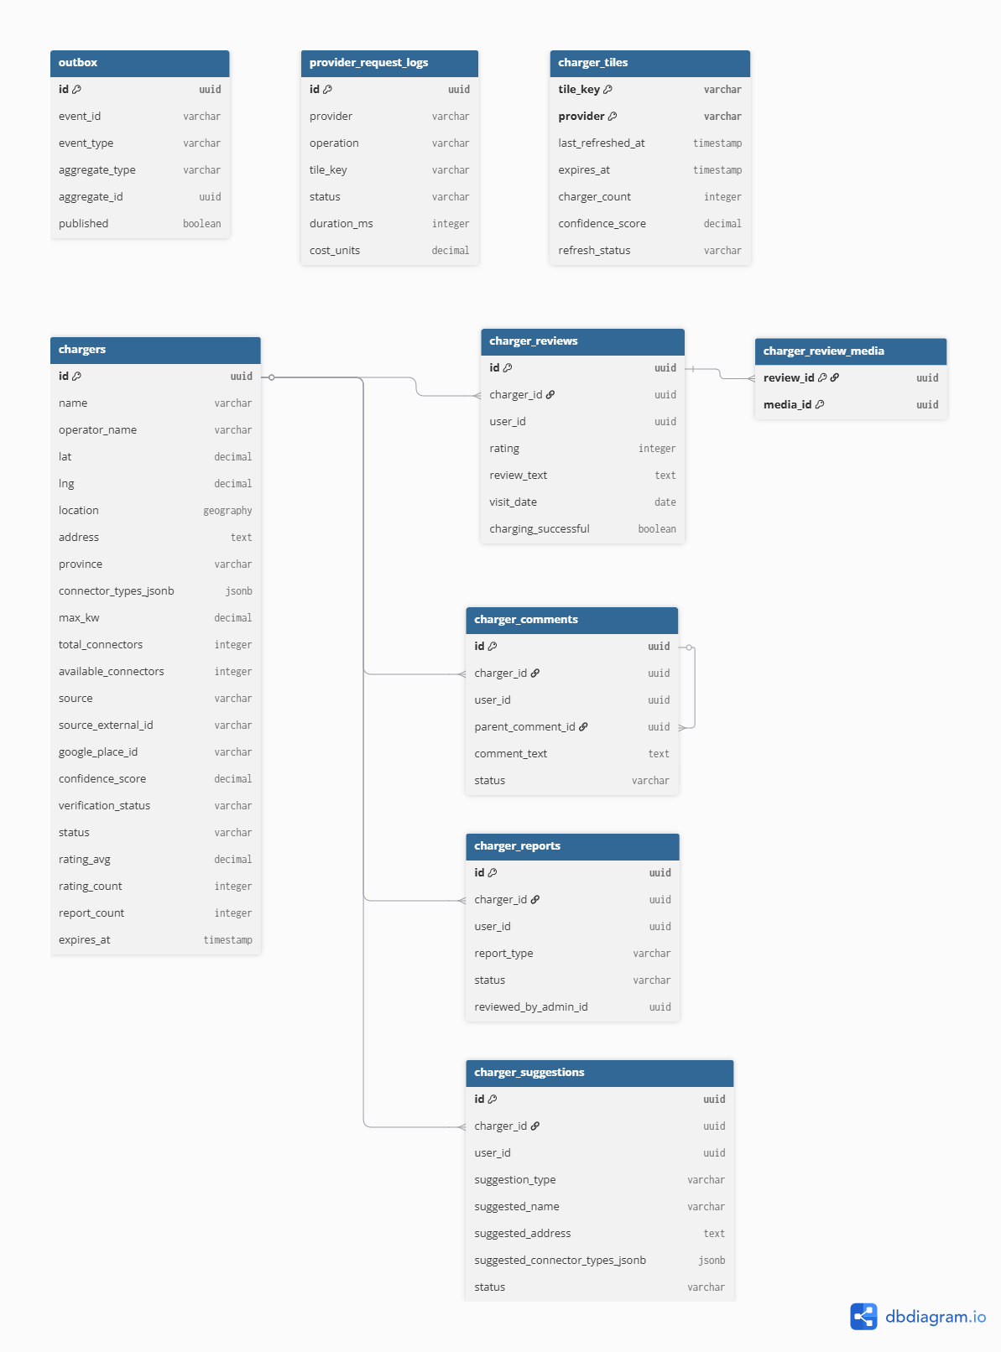
Figure 3.5: Shows EV ER Diagram

Figure 3.5 illustrates the ER Diagram of the EV Database, which manages charging station information, charger reviews, user feedback, and EV-related data used by the NAVIO platform. The database is centered around the chargers table, which stores detailed information about charging stations, including location, operator information, connector types, charging capacity, availability status, ratings, and verification records.
Charging Station Management: The chargers table serves as the primary entity of the database. It maintains charging station information collected from external providers and community contributions. Supporting tables such as charger_tiles and provider_request_logs are used to manage cached charger datasets and track data retrieval activities from external charging station providers.
Community Feedback: User-generated feedback is managed through the charger_reviews and charger_review_media tables. The charger_reviews table stores ratings, review content, and charging experiences submitted by users, while the charger_review_media table allows media files to be associated with specific reviews. These entities help improve the reliability and usefulness of charger information.
Community Interaction: The charger_comments table enables users to discuss charging stations, share experiences, and provide additional information. The table supports threaded discussions through parent-child comment relationships, allowing community members to engage in charger-related conversations.
Reporting and Suggestions: The charger_reports table allows users to report inaccurate, outdated, or problematic charger information for administrative review. Similarly, the charger_suggestions table stores user-submitted suggestions for updating charger details, including names, addresses, and connector information. These entities support continuous data improvement through community participation.
Event Processing: The outbox table supports the system's event-driven architecture by storing EV-related events before they are published to other services through the messaging infrastructure. This mechanism ensures reliable communication and synchronization between system components.
Overall, the EV Database provides a centralized repository for charging station management, community-driven feedback, and EV travel intelligence. Its structure supports accurate charger information, user participation, and continuous data maintenance within the NAVIO platform.

3) User (IAM) ER Diagram
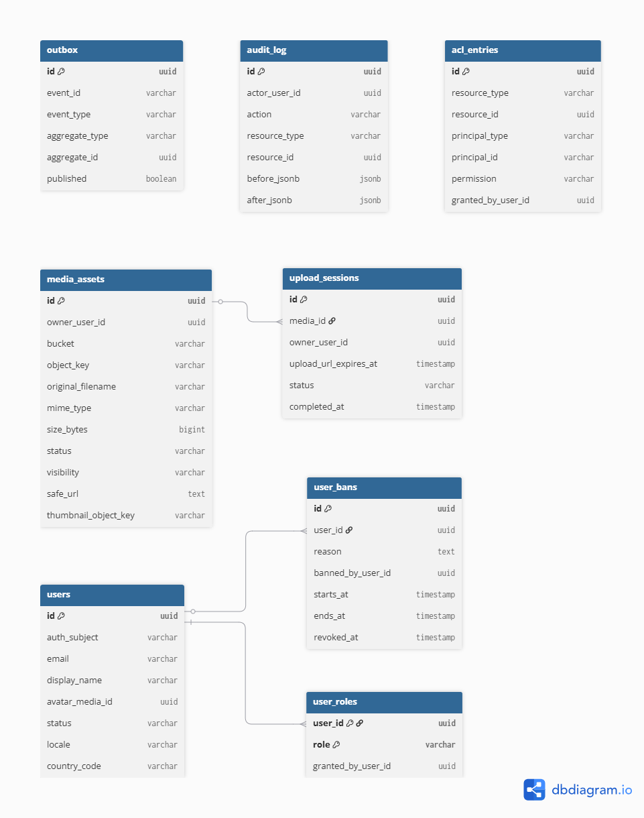
Figure 3.6: User ER Diagram
Figure 3.6 illustrates the ER Diagram of the User (IAM) Database, which manages user identities, authentication-related information, authorization controls, media assets, and administrative records within the NAVIO platform. The database serves as the foundation for access management and user account administration across all system modules.
User Management: The users table acts as the central entity of the database. It stores essential user information, including authentication identifiers, email addresses, display names, account status, locale settings, and profile media references. Most IAM-related entities are directly associated with this table.
Role and Access Control: Authorization is managed through the user_roles and acl_entries tables. The user_roles table assigns system roles to users, while the acl_entries table provides fine-grained access control by defining permissions for specific resources. Together, these entities ensure that users can only access functionalities and resources permitted by the system.
Account Moderation: The user_bans table stores records of suspended or restricted users, including ban reasons, duration, and administrative actions. This enables administrators to enforce platform policies and maintain community standards.
Media Management: User-uploaded files are managed through the media_assets and upload_sessions tables. The media_assets table stores metadata for images and other media resources, while the upload_sessions table tracks upload activities and file processing status. These entities support profile images and other media-related features across the platform.
Auditing and Event Processing: The audit_log table records significant user and administrative activities, providing accountability and traceability for system operations. In addition, the outbox table supports the event-driven architecture by storing domain events before they are published to other services, ensuring reliable communication between system components.
Overall, the User (IAM) Database provides the foundation for identity management, authorization, media handling, and administrative oversight, ensuring secure and controlled access throughout the NAVIO platform.

4) ER Diagram Notification Database
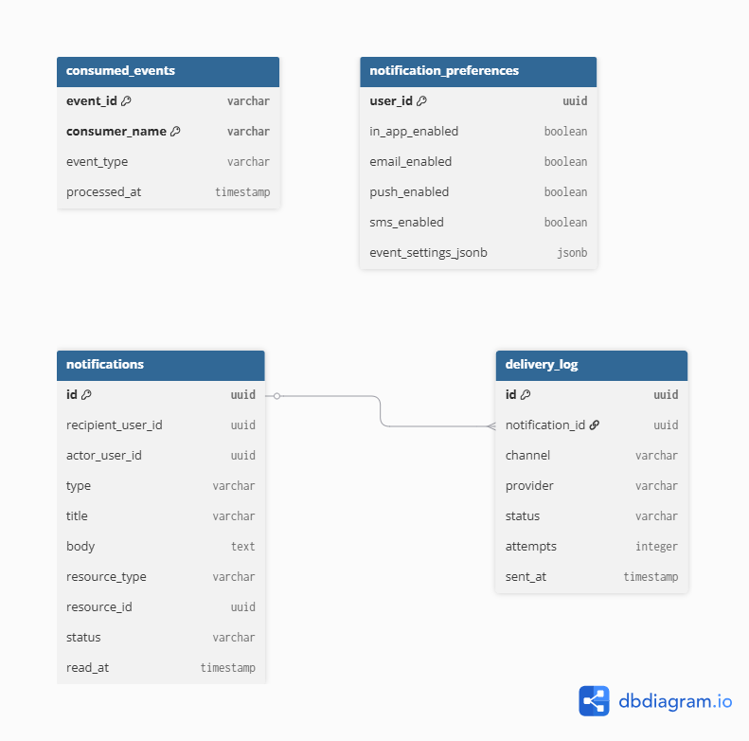
Figure 3.7: Shows Notification ER Diagram
Figure 3.7 illustrates the ER Diagram of the Notification Database, which manages user notifications, delivery tracking, notification preferences, and event consumption records within the NAVIO platform. The database ensures that users receive timely updates regarding trip activities, community interactions, system events, and other platform notifications.
Notification Management: The notifications table serves as the central entity of the database. It stores notification details such as the recipient, triggering user, notification type, content, related resources, delivery status, and read status. This table acts as the primary record for all notifications generated within the system.
Notification Preferences: The notification_preferences table stores user-specific notification settings. Users can configure their preferred notification channels, including in-app notifications, email, push notifications, and SMS. This allows the system to deliver notifications according to individual user preferences.
Delivery Tracking: The delivery_log table records notification delivery activities across different communication channels. It stores information such as the delivery provider, delivery status, number of attempts, and delivery timestamps. This enables monitoring and troubleshooting of notification delivery processes.
Event Processing: The consumed_events table supports the event-driven architecture by tracking events that have already been processed by the notification system. This prevents duplicate processing and ensures that notifications are generated reliably and consistently.
Overall, the Notification Database provides a structured mechanism for managing user notifications, delivery preferences, and event processing, ensuring effective communication between the NAVIO platform and its users.

5) Community ER Diagram
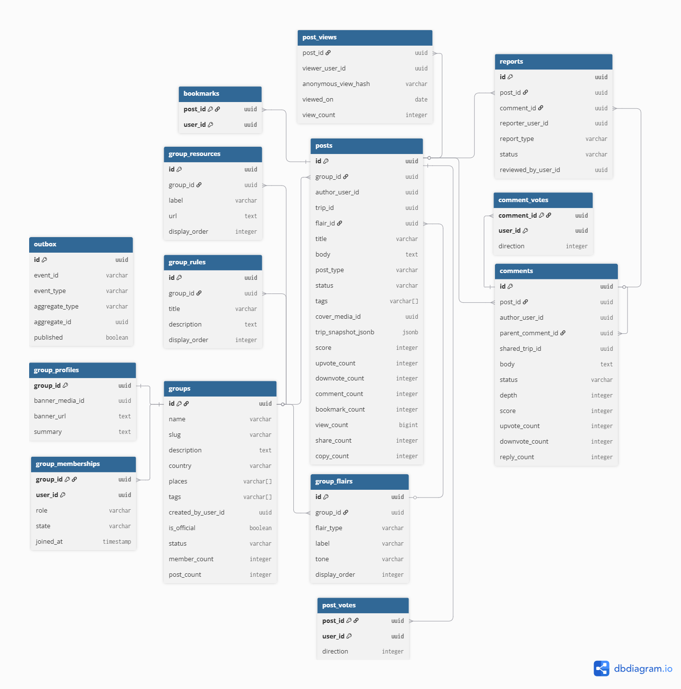
Figure 3.8: Shows Community ER Diagram

Figure 3.8 illustrates the ER Diagram of the Community Database, which manages community groups, discussion posts, user interactions, content moderation, and trip-sharing activities within the NAVIO platform. The database enables users to participate in EV-related discussions, share travel experiences, and engage with other community members.
Community Management: The groups table serves as the primary entity for organizing community spaces. Each group contains information such as its name, description, location coverage, tags, and membership statistics. Supporting entities including group_profiles, group_memberships, group_rules, group_resources, and group_flairs manage group appearance, membership records, community guidelines, shared resources, and post categorization.
Content Creation and Sharing: The posts table acts as the central entity for community content. It stores discussion posts, shared trip plans, announcements, and other user-generated content. Posts can be associated with specific groups and may reference shared trip information, allowing users to showcase and discuss travel plans within the community.
Community Interaction: User engagement is supported through the comments, post_votes, comment_votes, bookmarks, and post_views tables. These entities allow users to comment on posts, vote on content, save posts for future reference, and track content popularity through view statistics. Together, they encourage participation and content discovery within the platform.
Moderation and Reporting: The reports table supports content moderation by allowing users to report inappropriate posts or comments. Report records can be reviewed and managed by administrators to maintain community standards and ensure a safe discussion environment.
Event Processing: The outbox table supports the platform's event-driven architecture by storing community-related events before they are published to other services. This ensures reliable communication and synchronization between system components.
Overall, the Community Database provides the foundation for social interaction, trip sharing, content management, and community engagement within the NAVIO platform, enabling users to collaborate and share knowledge related to EV travel experiences.

6) AI ER Diagram
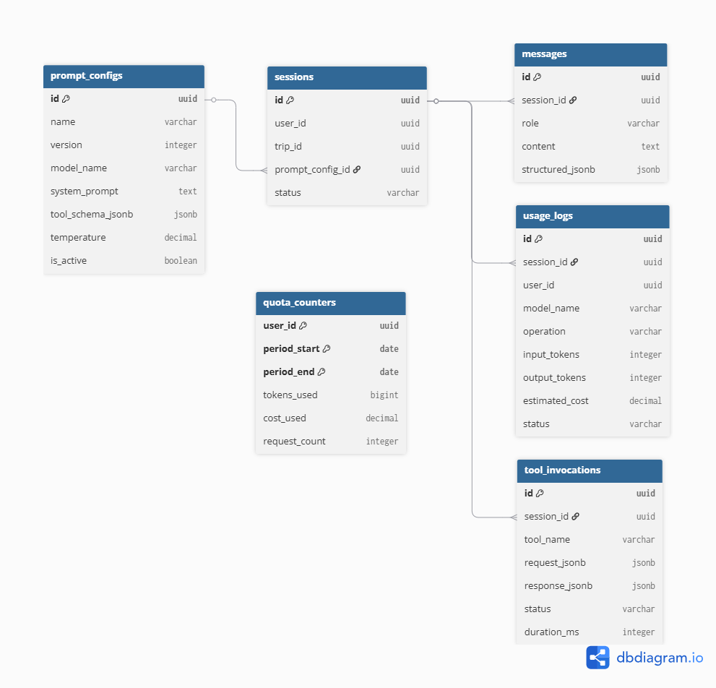

Figure 3.9: Shows AI ER Diagram

Figure X illustrates the ER Diagram of the AI Database, which manages AI conversations, prompt configurations, tool execution records, usage tracking, and resource consumption within the NAVIO platform. The database supports AI-assisted trip planning, itinerary generation, travel recommendations, and intelligent user interactions.
AI Configuration Management: The prompt_configs table stores prompt templates and model configurations used by the AI service. It contains information such as model settings, system prompts, tool schemas, and configuration versions, allowing AI behavior to be managed and updated consistently.
Session and Conversation Management: The sessions table serves as the central entity of the database and stores AI interaction sessions associated with users and trips. Each session can contain multiple conversation records stored in the messages table, which maintains the exchange between users and the AI assistant throughout a planning session.
Tool Execution Management: The tool_invocations table records tool calls performed by the AI service during conversations. It stores request data, generated responses, execution status, and processing duration, enabling the system to track AI-assisted operations and external tool usage.
Usage Monitoring: AI resource consumption is tracked through the usage_logs table. This table records model usage information such as token consumption, operation type, processing status, and estimated costs. These records support monitoring, auditing, and optimization of AI-related activities.
Quota Management: The quota_counters table maintains usage quotas for individual users within a specified period. It tracks token usage, request counts, and accumulated costs, allowing the system to enforce usage limits and ensure fair allocation of AI resources.
Overall, the AI Database provides the foundation for managing AI conversations, prompt configurations, tool integrations, and usage monitoring. Its structure enables reliable AI-assisted trip planning while maintaining operational control and resource management within the NAVIO platform.

Chapter 4 System Analysis & Design

Chapter 5 System Analysis & Design

References

Appendix

